How to Access Programs in Clever from Your Home Device

To access the learning programs in Clever from your home laptop or iPad

- clever.pwcs.edu

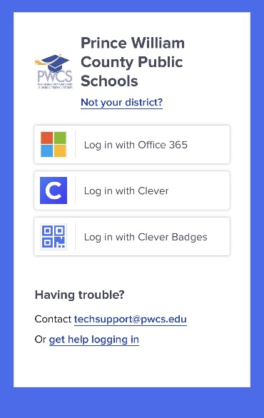
2. Choose Log in with Office 365

This log in is also at the bottom of the page on the MVES website Homepage. Office 365
3. You will need the student’s Microsoft username which is the full email address. Example: brxxxtj36@pwcs-edu.org
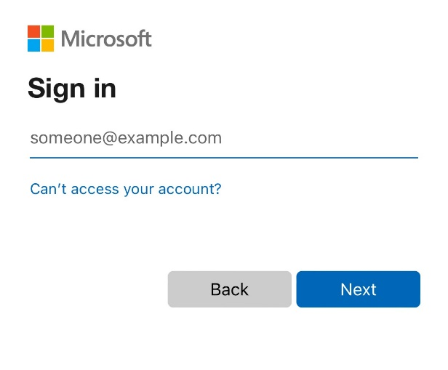
4. Enter student’s Microsoft password.

